- GENERAL GUIDELINES FOR PROPOSAL WRITING
- Topic: Any area including specialization; primary data or both primary & secondary data
- How many pages? No hard and fast rule, yet 10-15 pages (including references)
- Page no. location: Top right
- Font size Times New Roman 12; (in table may be reduced to if space is not enough)
- Paper margin-left 1.5” & 1”all sides
- Line space-1.5 (in table may be reduced to 1.15 if not fit)
- Text Alignment: Justified
Title page & Chapter heading: Centered
- Between paragraph gap: 6 points
- Never underline, but can use italics or bold
- Never use bullets • • • • , use roman numbers, e.g. (i), (ii), in sub point
- After every 3 digits from right, use comma, e.g. NRS. 10,000
- Citation (body note, no footnote)
- Print one side of the paper only
- No abbreviation & acronym to use they are first time used; you may use later
- Use formal & flawless professional English not colloquial: use simple & short sentences
- Use present tense or past tense; but mostly future tense is used in proposal.
- Paper size A4 size white; Page layout size A4.
- After proposal registration, dissertation viva must wait minimum of 60 days.
- 3 International research articles based & these articles to be attached with proposal

- PROPOSAL: CONTENTS
4 components:
(a) Title page: title font times new roman 14 bold ; other fonts times new roman 12
Title of the Proposed Dissertation
(Not too long)

A dissertation proposal submitted to the Office of the Dean,
Faculty of Management
in partial fulfilment
of the requirements for the Master’s Degree

by
Full Name of the Student
Roll No: ……..
Registration No:…….
Central Department of Management
Month, Year

(b) Table of contents: 2 columns: Contents and Page no.
(c) Body
  - Background of the study (page no. 1, with citations, 1-2 pages in paragraphs)
  - Problem statement(in paragraphs with citations; ending with about 3-4 research questions. Altogether1-2 pages)
  - Objectives of the study (use only action verb, e.g. to analyze, assess examine, identify, determine, explore, measure, compare). Write in roman number, e.g. i, ii, iii, iv, about ½ page
May use hypothesis if needed but not compulsory
  - Rationale of the study Justification/importance/significance of the study. Write in roman number, e.g. i, ii, iii, iv, v, vi, vii (½ page)
  - Limitations of the study (Write scope and limitation within the scope; geographical, organizational, methodology limitation. But never use such limitations as time, resource, partial fulfilment of master’s degree) Write in roman number, e.g. i, ii, iii, iv, v, vi, vii (½ page)
  - Literature review (brief, with citations, write in paragraphs with 2-4 pages)
6.1 Theoretical review (Review theories with citations of the text books)
6.2 Conceptual review (Review your topic variables, constants, citations of the text books)
6.3 Empirical review (Review research articles with citations of the journals)
6.4 Research gap (Highlight previous theoretical & empirical reviews in terms of the aspects they missed out but your proposal is addressing, of course supported with citations. E.g. research methodology gap, their limitations gap, objective gap, etc.)
  - Research methodology (brief in future tense in paragraphs, 2-3 pages)
  - Research design (e.g. descriptive, analytical research design, etc. & explain why that)
  - Population and sample (explain population, sampling frame, sample, sampling
Procedure. E.g. convenience sampling, etc. and explain why that.)
  - Nature and sources of data (e.g. primary source, secondary source or both)
  - Data collection instrument and procedure (e.g. questionnaire, interview, etc, how will)
  - Data processing procedure and data analysis method (e.g. how you plan to do so)
  - Research framework and definition of variables (e.g. independent and dependent variables along with citation of the source; followed by the definition of the variables)
9. Expected results (expected result of each of the objectives, write in roman no. i, ii, iii, iv,)
10. Chapter plan (brief explanation of all the 5 chapters, e.g. chapter 1. Introduction 2. Literature Review 3. Research Methodology 4. Results and Discussion 5. Summary and Conclusion. 1/2 page)
(d) References (1/2 page) too contains page no.
# direct quote (i.e. “It is stated that….”), page no. (Shrestha, 2014, pp.122-123); indirect quote no page number is required. (Davis & Whalen, 2001).
- GUIDELINES FOR PPT PRESENTATION OF PROPOSAL
- First of all watch all the dissertation writing videos on this youtube site
https://www.youtube.com/channel/UCufw3nXT5yQd1-wbiddcl1g
- Submit the following 4 documents to CDM by Friday for the next Tuesday’s viva
- Proposal document (in MS word) (ii.) Power Point Template (PPT) slides
- Base articles (3) (iv ) Voucher of proposal fees deposited (later due to COVID19)
- Every Tuesday 11 am onwards proposal viva voce takes place
In the PPT slides
- Font types and size should be same: Times New Roman 32
- Slides should be very concise/short: No sentences to write ; only words/phrases
- Come prepared for viva; be precise/to the point; Speak loud & confident with eye contact
- After proposal viva, do needful correction as per (i) experts’ comments and resubmit it.
- No bullets to use in the PPT ; use Roman Number (i, ii, iii, iv) instead
- About 13 slides (with slide number & date)
Slide no. | Titles and contents
Slide 1 | Title of proposal along with the name of researcher (phone, email, roll)
Slide 2 | - Problem statement (write in roman number i, ii, iii,…)
Slide 3 | - Research questions (write in roman number i, ii, iii, iv…)
Slide 4 | - Objective of the study (i, ii, iii, iv…) Hypothesis if any, then use slide 5
Slide 5 | - Conceptual framework (with source citation)
Slide 6 | - Limitations of the study (write in roman number i, ii, iii, iv, v, vi,…)
Slide 7 | - Research gap (of previous empirical research; with citations)
Slide 8 | 8.1 Research methodology (Research design, population, sampling, etc.
 | 8.2 Research methodology (Data sources, data collection, analysis tools)
Slide 9 | 9. Expected results (of each of the objectives set)
Slide 10 | References

- thesis format
3 sections:
(a) Prefatory
(b) Body: 5 Chapters: I. Introduction II. Literature Review III. Research Methodology IV. Results and Discussion V. Summary and Conclusion
(c) Supplementary

Table of Contents

Contents Page NO.
Title Page ……………………………………………………………………………………….…......i
Certificate of Authorship…………………………………………………………………….……….ii
Report of Research Committee……………………………………………………….……………..iii
Approval Sheet………………..………………………………………………………………………..iv
Acknowledgements…………………………………………………………………………..…………v
Table of Contents………………………………………………………………………………………vi
List of Tables……………………………………………………………………………………….….viii
List of Figures…………………………………………………………………………………………...ix
Abbreviations………………………………………………………………………………………..…..x
Abstracts………………………………………………………………………………………………....xi
CHAPTER 1: INTRODUCTION……………………………………….…………….…1-6
  - Background of the study…………………………………………………………….…1
  - Problem statement ……………………………..………………………………….…...3
  - Objectives of the study……………………………..………….……………...………...4
Hypothesis (If any)……………………………………………………………………….
  - Rationale of the study………….………………………………………………………..5
  - Limitations of the study…………………………………………………………………5
  - Chapter plan………….…………………………..……………………………………...6

Chapter 2: Literature review………………………………………………..7-25
2.1 Introduction……………………………………………………………………………....7
2.2 Theoretical review ……………………………………………………………………….7
2.3 Empirical review………………………………………………………………………..15
2.3.1 Review of journal articles ………………………………………………..……….15
2.3.2 Review of previous theses…………………………..…………………………….18
2.3.3 Summary of articles and theses…………………………………………………..23
2.4 Research gap…………………………………………………………………….……..…25
Chapter 3: Research Methodology……..…………………………………26-32
  - Introduction………………………………………………………………………….…26
  - Research design ………………………………………………………………………..26
  - Population, sample, and sampling design...……………………………………….….27
  - Nature and sources of data……….……………………………….……………………27
  - Data collection instrument and procedure.…………………………………………...28
  - Data processing procedure and data analysis method……………………...……..…28
  - Research framework and definition of variables………………………………….….30
Chapter 4: RESULTS and Discussion..…………….…………………..….…. 33-53
4.1 Results ………………..……….……………………….....................................................33
4.1.1 Data presentation and analysis…………………………………………………....33
4.1.2 Findings………………………………………………………………...…………..49
4.2 Discussion………………………………………………..……………………..………...52
CHAPTER 5: SUMMARY AND CONCLUSION………………………… ……….…54-59
5.1 Summary……………………..………………………………………………………… 54
5.2 Conclusion ………………………………………………………………………………57
5.3 Implications………………………………………………………………………….…..58
REFERENCES………………………………………………………………………….…..60
APPENDICES ……………………………………………………………………………...63

- GENERAL GUIDELINES FOR DISSERTATION WRITING
- How many pages: No hard and fast rule, but 50 plus pages (excluding appendices)
- Page no. position: Top right
- Font: Times New Roman size 12; (in table, may be reduced if does not fit into the page)
- Page margin-left 1.5” & 1”all sides
- Line space-1.5 (in table, may be reduced to 1.15 if does not fit into page)
- Text Alignment: Justified
- Title page & Chapter heading: centered
- Between paragraph gap: 6 points
- Never underline, but can use italics or bold
- Never use bullet • • • •, but use roman number (i), (ii), (iii), (iv) in sub point
- Use comma after every 3 digits from the right, e.g. NRS. 10,000
- Citation (body note) if direct quote: (Shrestha, 2011, p.25); no page no. for indirect quote.
- Print one side of the paper only
- No abbreviation & acronym to be used when first time used, but later can be used
- Formal, professional, flawless standard English not colloquial: Simple & short sentences
- Use present tense or past tense
- Paper size A4 size white; Page layout size A4.
- Page no. starts as 1 at the chapter 1: Introduction and continues with references and even to appendix
- Dissertation viva can happen after expiry of 2 months of proposal registration date
- First 1 loose copy of dissertation to be submitted to Research committee for viva voce and after viva voce the comments of internal and external experts are incorporated and approved from internal expert, external expert, supervisor, and research head, only then 4 copies of dissertation have to be printed and duly signed by all and submitted to the CDM.

- DISSERTATION CONTENTS
- 3 sections: (a) Prefatory (b) Body (c) Supplementary
- PREFACTORY SECTION
Pagination: ii, iii,
- Title Page
(Centered, counted as page no. “i”, but does not appear); all bold, not long, no acronym/abbreviation

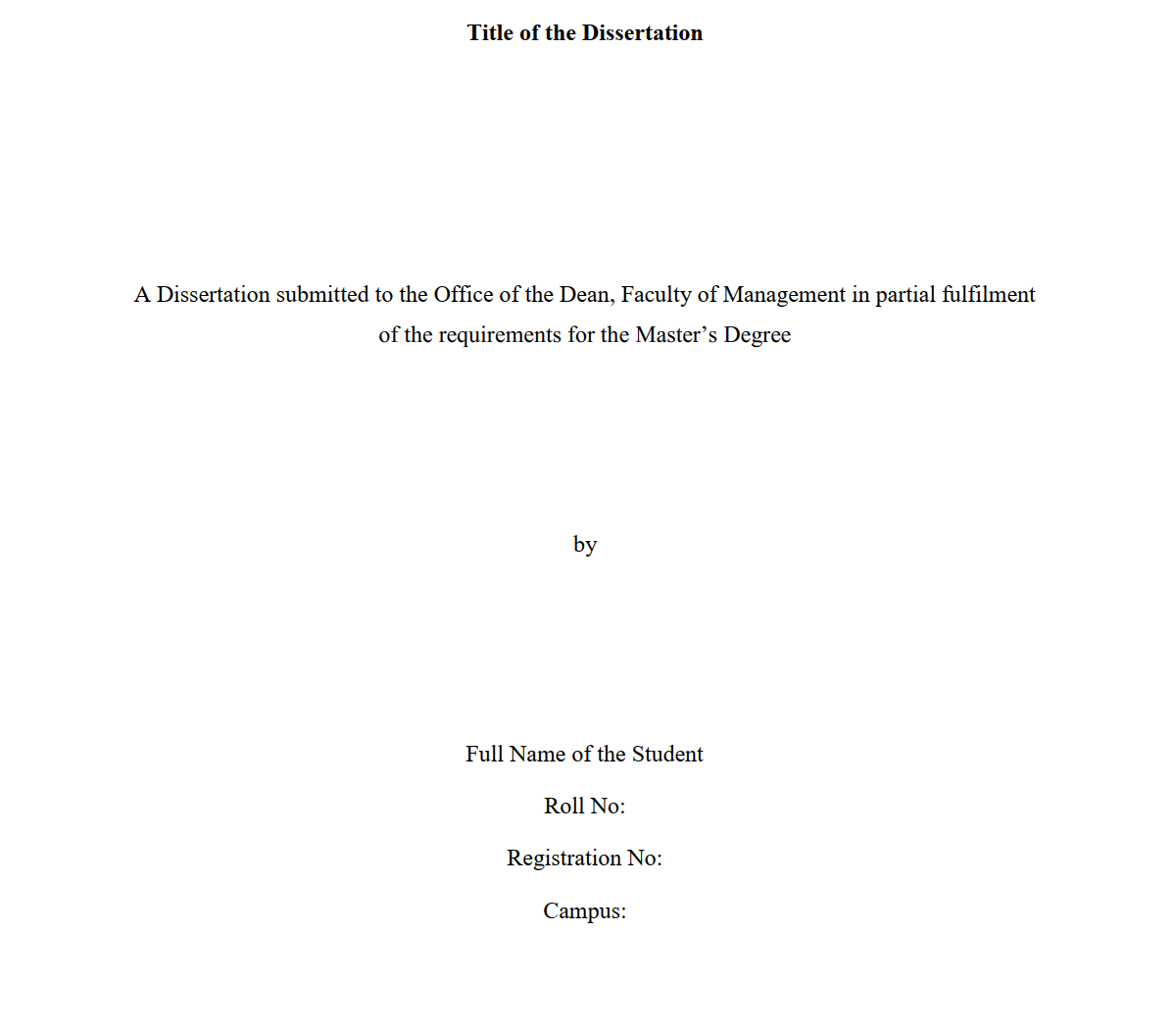
Submission date (month and year)

- Certificate of Authorship
- Signed (Researcher); counted as page no. ii, appears on the text

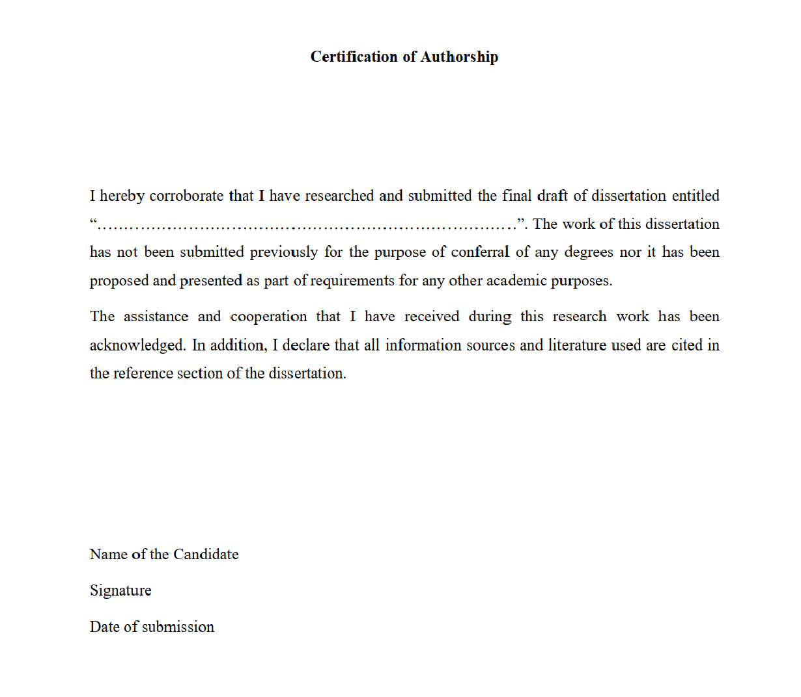

- Report of Research Committee
- In the Institutional letterhead, e.g. CDM letterhead; page counted as “iii”, but does not appear

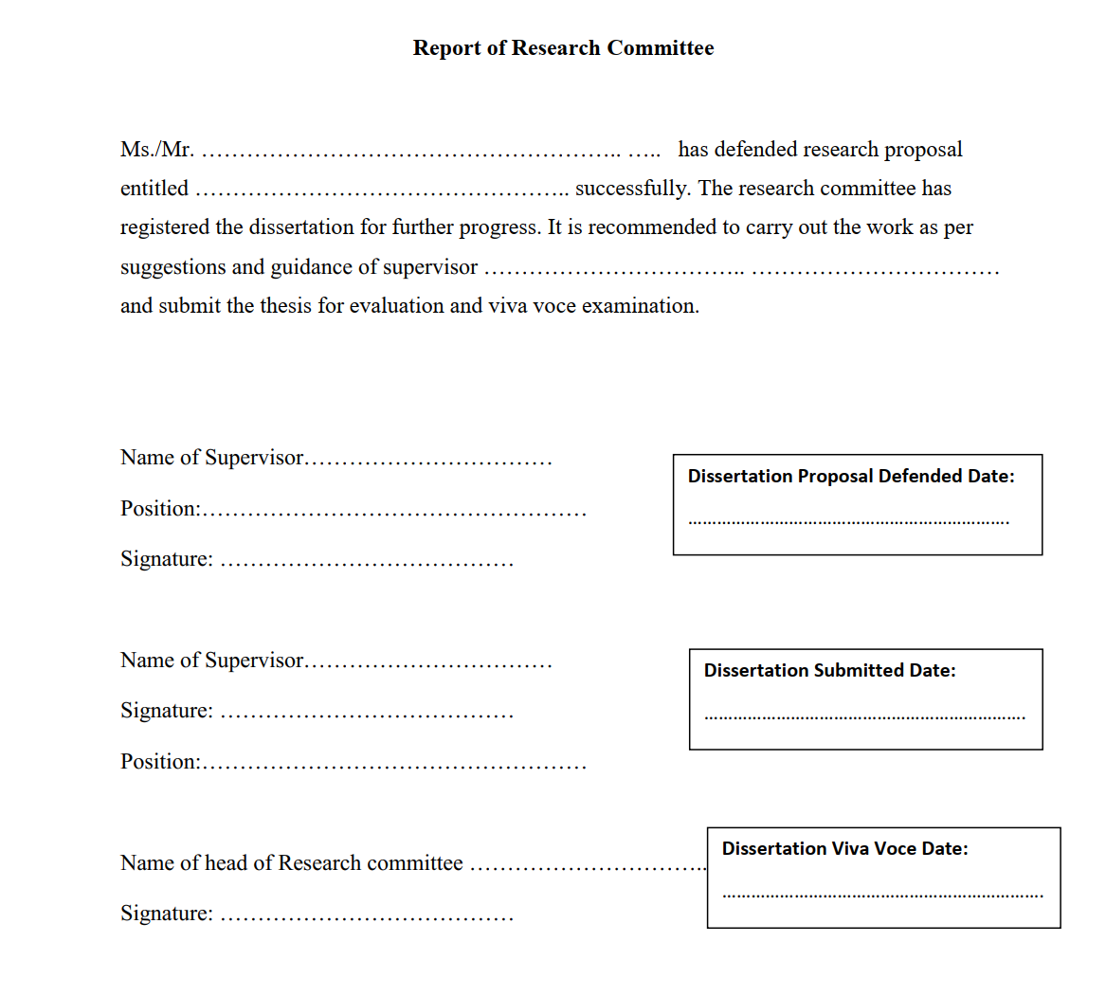

- Approval Sheet
- Institutional letterhead, e.g. CDM letter head; page no as “iv” but does not appear

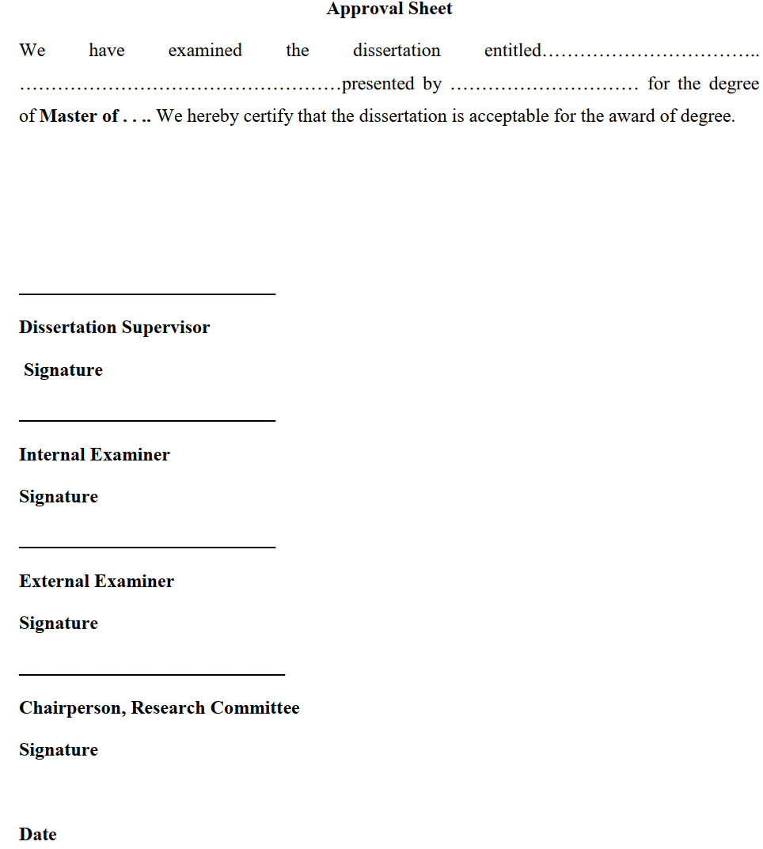

5. Acknowledgements (1 page)
- Page no. as “v” and appears on the text; express gratitude to all, type your name, but no sign
6. List of Contents
Page no. “vi” & “vii” and appears on the text
7. List of Tables
Page no. “viii” appears on the text,
8. List of Figures
Page no. appears as “ix” on the text
9. Abbreviations
Page no. appears as “x” on the; arrange the abbreviations alphabetically
10. Abstract
- Page no appears as “xi”
- Centered non-bold
- Single paragraph (150-200 words) block format within 1 page
- Non italics
- Concise, objective, specific summary of most important points; without evaluation/opinion
(in abstract: Objective, methodology, findings, conclusions, and implications) 3-5 key words
(b) BODY
- Coherent (art of storytelling) presentation of relevant information in organized & logical. Evidence with pertinent chart, graphs, data, pictures etc.
- Title of the chapter: New Times Roman font 12 all caps bold.
- Use new page to start new chapter
- 5 chapters : (1) INTRODUCTION (2) LITERATURE REVIEW (3) RESEARCH METHODOLOGY (4) RESULTS AND DISCUSSION (5) SUMMARY AND CONCLUSION

CHAPTER 1: INTRODUCTION
1.1 Background of the study (page no. 1. Topic contents, focus of study; with citations, 2-3 pages in write in paragraphs, literature review based so supported with citations)
1.2 Problem statement issues/problems/challenges/opportunities; literature review based so with citations, write in paragraphs; ending with 3-4 research questions in points i, ii, iii, iv; altogether 1-2 pages.
1.3 Objectives of the study (general & specific objective; use only action verbs: examine, analyze, assess, measure, identify, compare; general objectives in paragraph and specific objectives to be written in roman number i, ii, iii, iv.)
May use hypothesis if needed but not compulsory (if used then relate with answers to the research questions) (all together 1-2 pages)
1.4 Rationale of the study (justification/significance/importance of study (½ page) write in roman numbers i, ii, iii, iv)
1.5 Limitations of the study (Write scope and limitations within the scope. Geographical, organizational, methodology limitations. But never use such limitations as time, resource, partial fulfilment of master’s degree) Write in no. i, ii, iii, iv, v, vi, vii (scope, delimitations, etc.)
1.6 Chapter plan (brief explanation of all the 5 chapters, e.g. chapter 1. Introduction 2. Literature Review 3. Research Methodology 4. Results and Discussion 5. Summary and Conclusion.
Note: Citation: (Cronbach & Meehl, 1959) ampersand (&) is used not “and”
CHAPTER 2: LITERATURE REVIEW (10-20 pages, all in paragraphs)
2.1 Introduction (link chapter 1 & 2; explain chapter contents) (½ page)
2.2 Theoretical review (Review theories all in paragraphs with citations of the text books)
2.3 Conceptual review (Review your topic variables, constants, citations of the text books)
2.4 Empirical review (Review of Issues, objectives, methodology, conclusion)
2.3.1 Review of journal articles (all in paragraph with citations)
2.3.2 Review of previous theses (all in paragraph with citations)
2.3.3 Summary of articles and theses (in tabular form)

2.4 Research gap
(Highlight previous theoretical & empirical reviews in terms of the aspects they missed out but your proposal is addressing, of course supported with citations. E.g. research methodology gap, their limitations gap, objective gap, etc.) 1-2 pages, supported by citations.
CHAPTER 3: RESEARCH METHODOLOGY
3.1 Introduction (link chapter 2 & 3; explain chapter contents)
-No theory, methodology used actually, past/present tense
3.2 Research design (e.g. descriptive, analytical research design, etc. & explain why that)
3.3 Population, sample, and sampling design (explain population, sampling frame, sample, sampling procedure. E.g. convenience sampling, etc. and explain why that was used.)
3.4 Nature and sources of data (primary sources only, secondary sources only or both)
3.5 Data collection instruments and procedure
(e.g. questionnaire, interview, etc, how will actual steps)
3.6 Data processing procedure and data analysis method
(Explain how you actually did. E.g. specific statistical & financial tools like mean, correlation, regression, T test etc.’ Likert-measurement scale, software SPSS with version)
  - Research framework and definition of variables
(Conceptual framework, e.g. independent and dependent variables along with citation of the source; followed by the definition of the variables)
CHAPTER 4: RESULTS AND DISCUSSION
  - Results
4.1.1 Data Presentation and Analysis
-answer the research questions posed or test the hypotheses (support or reject)
-Present, describe, interpret tables/figures as table no. 4 not above table or below table: trend ; Describe only special/critical data not each; table (single-spaced)
-inapplicable data: leave cell blank; unreported date: dash (-) in the cell
-abbrv. in table, full form below the table; no table break across pages (reduce font/line space in order to avoid table breaking into another page)
-No statistical/financial computation is to be shown as they are done using excel/SPSS
4.1.2 Findings
-Quantitative data supported summary of chapter 4 (align with each objective)
-Write in roman letters i, ii, iii, iv, v, vi, vii, viii, ix, x, ………………
  - Discussion
-Compare & interpret our results/findings (Y) with theories & empirical findings of other researchers or hypotheses (X) (i.e. chapter 2). Y=X; Y is not equal to X
-Reasons of difference/contradiction?? Reasons of similarity??? Why reject hypotheses?
-How can you explain this? Sources of potential bias, imprecision of measures, effect of sample size or sample bias? methodological limitations & weaknesses. Think about what you
would do different next time if you conducted a similar study. Future research ideas are often
discussed when limitations are discussed. Must be supported by citations.
-discussions should clearly lead to arrive at conclusion and implication (deferred to next section)
-discussion should be in paragraphs and with citations.
CHAPTER 5: SUMMARY AND CONCLUSION
5.1 Summary
(of all 4 chapters not 5th, i.e. statement of problem, research question, objective, rationale, limitation, research gap, methodology, findings, and up to discussion)
-should be in paragraphs
5.2 Conclusion
-(Based on findings, discussion) each objective wise conclusion of the present research
-should be in paragraphs
5.3 Implications
(present research result based, not opinionated statement)
-Implication to policy makers; practitioners (practical application); academic community (i.e. theory); areas for future research (due to limitation of present research); What you do next time with same research; describe the implications of your findings to theory and practice
-Should be in points i, ii, iii, iv, v, vi, vii, viii, ix, x

(c) SUPPLEMENTARY
- Page no. continues throughout references & appendices
1. References
(differs from bibliography)
Books (General Format)
Hewson, C., Vogel, C. M., & Laurent, D. (2016). Internet research methods (2nd ed.). Los
Angeles, Calif.: Sage Publication.
Group or Corporate Author (author is same as publisher)
American Diabetes Association. (2015). The Diabetes dictionary: What every person with
diabetes needs to know. Alexandria, VA: Author
Government Agency as Author
U.S. Census Bureau. (2006). Statistical abstract of the United States (125th ed.). U.S.
Government Printing Office.
Magazine Article
Grossman, L. (2016, March 28). Inside Apple’s code war: The world’s most powerful
tech company is fighting the FBI on terrorism. Time, 187, 42-49.
(Here, 187 is volume number, 42-49 page no. )
Journal Article (e.g. volume 70, issue 1)
Struckmeyer, L. R. (2016). Home modifications for people with Alzheimer‟s Disease: A scoping
review. American Journal of Occupational Therapy, 70 (1), 1-9.
2. Appendices
Detailed tables/charts/figures/master schedules/consolidated balance sheet/consolidated P/L Account, Questionnaire if any

- GUIDELINES FOR PPT PRESENTATION OF DISSERTATION
In the PPT slides
- Font types and size should be same: Times New Roman 32
- Slides should be very very short: No sentences to write ; only words/phrases
- Come well prepared for viva; be precise & to the point
- Speak loud & confident: Maintain eye contact
- After dissertation viva needful correction as per (i) experts’ (external & internal) comments
- No bullets to use ; use Roman Number (i, ii) instead
- About 13 slides (with slide number & date)
Slides no. | Titles and contents
Slide 1 | Title of thesis, name of the Researcher (phone, mail, roll) & Supervisor
Slide 2 | 1. Problem statement (write in roman number i, ii, iii,…)
Slide 3 | 2. Research questions (write in roman number i, ii, iii,…)
Slide 4 | 3. Objective of the study (i, ii, iii,…) Hypothesis if any, then use slide 5
Slide 5 | 4. Conceptual framework (with source citation)
Slide 6 | - Limitations of the study (write in roman number i, ii, iii,…)
Slide 7 | - Research gap (of previous empirical research; with citations supported)
Slide 8 | 7.1 Research Methodology (Research design, population, sampling etc.
 | 7.2 Research Methodology (Data sources, data collection, analysis tools)
Slide 9 | 8.1 Results (Summarized numerical values in master tables)
 | 8.2 Results (Summarized numerical values in master tables)
 | 8.3 Results (Summarized numerical values in master tables)
Slide 10 | 9. Findings (Summary of results supported by quantitative data, write i, ii, iii,)
Slide 11 | 10. Discussion (if your findings support or contradict theories & previous findings; must be supported with citations)
Slide 12 | 11. Conclusion (In alignment with objectives of the study, write in i, ii, iii,…)
Slide 13 | 12. Implication (Recommendation to …e.g. like future researchers, write in i, ii)

Slides | Titles and contents
SLIDE 1 | TITLE OF THESIS along with the name of the Researcher & Supervisor
SLIDE 2 | STATEMENT OF THE PROBLEM (i, ii, iii,…)
SLIDE 3 | RESEARCH QUESTIONS (i, ii, iii,…)
SLIDE 4 | OBJECTIVE OF THE STUDY (i, ii, iii,…)
SLIDE 5 | LIMITATIONS OF THE STUDY (i, ii, iii,…)
SLIDE 6 | RESEARCH GAP (how your thesis differs from previous theses)
SLIDE 7 | 7.1 RESEARCH METHODOLOGY (Research design, population, sampling etc.
 | 7.2 RESEARCH METHODOLOGY (Data sources, data collection, analysis tools)
SLIDE 8 | 9.1 RESULTS (Summarized numerical values in master tables)
 | 9.2 RESULTS (Summarized numerical values in master tables)
 | 9.3 RESULTS (Summarized numerical values in master tables)
SLIDE 9 | MAJOR FINDINGS (Summary of results supported by data)
SLIDE 10 | DISCUSSION (if your findings support or contradict theories & previous findings)
SLIDE 11 | CONCLUSION (In alignment with purpose of the study, i, ii, iii,…)
SLIDE 12 | IMPLICATION (Recommendation to stakeholders like future researchers,

